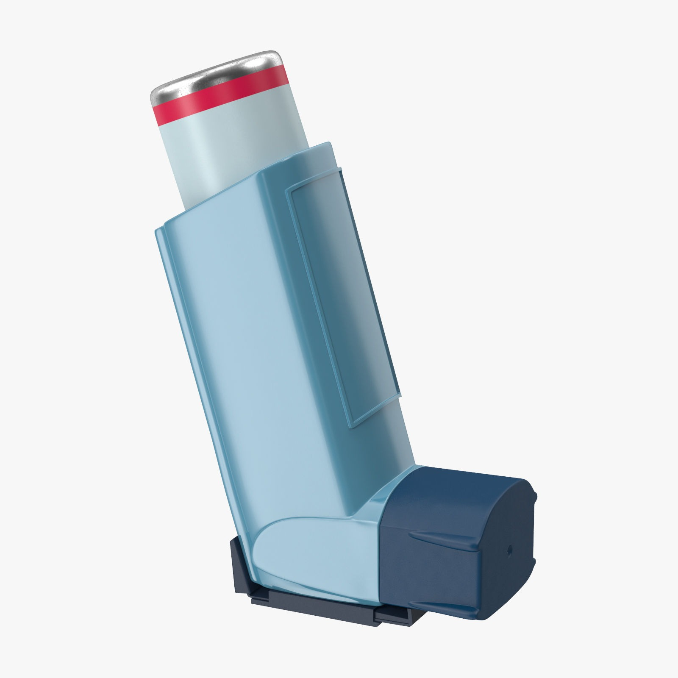

COPD Review

|  |
| --- |
| **CONTACT DETAILS** |

Name: 

Date of Birth: 

(dd/mm/yyyy)

Mobile Phone: 

Email: 

|  |
| --- |
| **QUESTIONNAIRE** |

**1.**When was your COPD diagnosed?       

**2.**In the last month, did you have any difficulty sleeping because of COPD symptoms (including cough)?



**3.** In the last month,how severe had been your

breathlessness   ?

Choose an item.

**4.**How often do you use your Asthalin/Levolin inhaler? 

**5.**Do you have any swelling of the legs or abdomen?



Yes

**6.**Have you ever had Spirometry done?



Yes

*If yes, do you know your best FEV1 value*

 ml

**7.**How much is your Hemoglobin? (gm/dl) 

**8.**Did your Spo2 level go below 92%?



**9.**Do you think your inhaler technique is correct?



Yes

*If not, there is an online demonstration on*[*the Asthma UK website*](http://www.asthma.org.uk/knowledge-bank-treatment-and-medicines-using-your-inhalers)

***10****.*Have you ever been demonstrated inhaler technique by your physician or nurse?

**

Yes

**11.**Have you ever smoked?



Yes

*If 'Yes', please answer the following:*

Do you smoke now?



Yes

If 'Yes' how many do you smoke each day?



There are plenty of options available to help you quit. Is this something you would like us to contact you about?

No

Yes

**12**.Have you ever been prescribed oral steroids due to exacerbation of COPD ?

No

Yes

**13.**Have you ever been hospitalized due to COPD ?

No

Yes

If yes then how many times ? 

**14**.Over the past 2 weeks did you have little interest or pleasure in doing things for more than half the days?

No

Yes

**15**. Over the past 2 weeks did you have little interest or pleasure in doing things for more than half the days?





16.Tick whatever information is True:



|  |
| --- |
| **Please mail the completed Questionnaire to** [**drarghyabanerjee@gmail.com**](mailto:drarghyabanerjee@gmail.com) |

**Note:**  
By submitting this form you will be sending information about yourself across the Internet. Whilst every effort is made to keep this information secure, guarantees of absolute privacy cannot be assured of.

Source: Primary Care Respiratory Society UK Opinion